**Name:**Ruchita Paithankar(Dusane)

**Duration :** 1Feb-1March

**Subject:** Tweeter Analytics Power Bi

**Submission Date:**28-02-2025

**Internship Report of Tweeter Analytics.**

**Introduction:**

During my internship, I was tasked with developing a Power BI dashboard to analyze tweet engagement metrics with specific conditions and time-based visibility rules. This project enhanced

**Introduction:**

my skills in data visualization and advanced filtering techniques in Power BI.

The project was undertaken to analyze tweet engagement data using advanced Power BI functionalities. In an era of digital communication, understanding social media interactions is crucial for strategic decision-making. The dashboard aimed to provide in-depth insights into tweet performance, focusing on engagement rates, media interactions, and content analysis. This required implementing complex conditions, such as time-based visibility and dynamic filters, to ensure accurate and relevant data presentation. The project not only demanded technical expertise but also strategic thinking to derive actionable insights from social media analytics.

**Background:**

* The objective of the project was to provide meaningful insights into tweet engagements while applying complex filtering criteria such as character count, word exclusions, time-based visibility, and conditional metrics.
* This required a deep understanding of Power BI’s DAX functions and visualization capabilities.

**Learning Objective:**

* The primary objective of the internship was to leverage advanced Power BI functionalities to create dynamic, data-driven dashboards.
* This involved mastering DAX formulas, implementing time-based visibility, and applying complex filtering rules.
* Understand Tweet data.
* Transform data.
* To understand all Power Bi filtering technic for maintaining data.
* To analyze and manage Tweet data.
* To enhance DAX function.
* To use applying time DAX.

**Activities and Tasks:**

1. Develop a chart that displays tweets with the highest engagement rates (top 10%). Include only those tweets that have received more than 50 likes and were posted on weekdays and this graph should work only between 3PM IST to 5 PM IST apart from that time we should not show this graph in dashboard itself as well as tweet character count should be below 30.  
     
   2. Plot a scatter chart to analyse the relationship between media engagements and media views for tweets that received more than 10 replies. Highlight tweets with an engagement rate above 5% and this graph should work only between 6PM IST to 11 PM IST apart from that time we should not show this graph in dashboard itself and the tweet date should be odd number as well as tweet word count be above 50.  
     
   3. Create a line chart showing the trend of the average engagement rate over each month of the year. Separate the lines for tweets with media content and those without and this graph should work only between 3PM IST to 5 PM IST and 7 AM to 11AM apart from that time we should not show this graph in dashboard itself and the tweet engagement should be even number and tweet date should be odd number as well as tweet character count should be above 20 and need to remove tweet word which has letter 'C'.

**Skills and Competences:**

This internship provide me opportunity to both analytics and technical skills.

* In that I am learn about advance knowledge of DAX and filtering data and transforming data, Cleaning data technique. Advanced knowledge of Power BI’s DAX functions for dynamic filtering and calculations, enabling complex data manipulations and conditional logic.
* Expertise in time-based visibility and conditional rendering of visuals to enhance dashboard interactivity and relevance.
* Proficiency in designing complex data models and dashboards, ensuring scalability and maintainability.
* Strategic thinking for data-driven decision-making, optimizing social media performance analysis.
* Expertise in time-based visibility and conditional rendering of visuals.
* Proficiency in designing complex data models and dashboards.
* Analytical skills for interpreting tweet engagement data.

**Feedback and Evidence:**

During the internship, I received constructive feedback from my project supervisor and team members. They appreciated the innovative approach to using time-based filtering and the effective visualization of complex data patterns.

To support the feedback, I provided detailed documentation on the DAX calculations and filtering logic used in the dashboard. I also conducted presentations to demonstrate the functionality and impact of the visualizations, receiving positive feedback on the ease of navigation and the actionable insights delivered by the dashboard.

Feedback from the project supervisor highlighted the innovative use of time-based filtering and the effective visualization of complex data patterns. The dashboard was praised for its clarity and relevance to user engagement analysis

**Challenges and Solutions:**

* Time-based Visibility: Implementing time-based visibility required mastering DAX functions related to time intelligence. The challenge was solved by creating custom time filters and adjusting data refresh settings. I also experimented with dynamic measures to control the visibility of visuals based on system time.
* Complex Filtering Requirements: Managing multiple conditional filters, such as character count, word exclusions, and odd/even conditions, demanded efficient DAX coding practices. This was achieved through iterative testing, breaking down complex formulas into manageable components, and optimizing for performance.
* Data Modeling and Relationships: Ensuring accurate data relationships and avoiding circular dependencies was challenging due to the complex data model. This was resolved by carefully planning the data schema and leveraging Power BI’s calculated tables and measures.
* Performance Optimization: The complex calculations and filters initially led to slower dashboard performance. To optimize it, I implemented query reduction techniques and minimized the use of volatile DAX functions.
* Each challenge was an opportunity to deepen my knowledge of Power BI and enhance my problem-solving abilities. By overcoming these obstacles, I developed a robust and efficient dashboard that met all requirements.
* Implementing time-based visibility required mastering DAX functions related to time intelligence. The challenge was solved by creating custom time filters and adjusting data refresh settings.
* Managing multiple conditional filters and exclusions demanded efficient DAX coding practices, which were achieved through iterative testing and optimization.

**Outcomes and Impact:**

The internship project delivered substantial outcomes and had a significant impact, both on my professional growth and the stakeholders involved:

* Successfully delivered a dynamic Power BI dashboard that provides actionable insights into tweet engagements, enhancing decision-making for social media strategies.
* Gained in-depth experience in advanced Power BI functionalities, including DAX, dynamic filtering, and time-based visibility, which significantly improved my technical proficiency.
* The dashboard is now a valuable tool for analyzing tweet engagement patterns with precision, helping the organization optimize content strategies and audience targeting.
* Enhanced my problem-solving and analytical thinking skills by overcoming complex challenges related to conditional filters and data modeling.
* Received positive feedback from stakeholders for delivering a user-centric dashboard that facilitates data-driven decision-making.

This project not only contributed to my skill development but also provided the organization with a powerful analytical tool for social media engagement analysis, impacting strategic decision-making processes.

**Screenshots:** 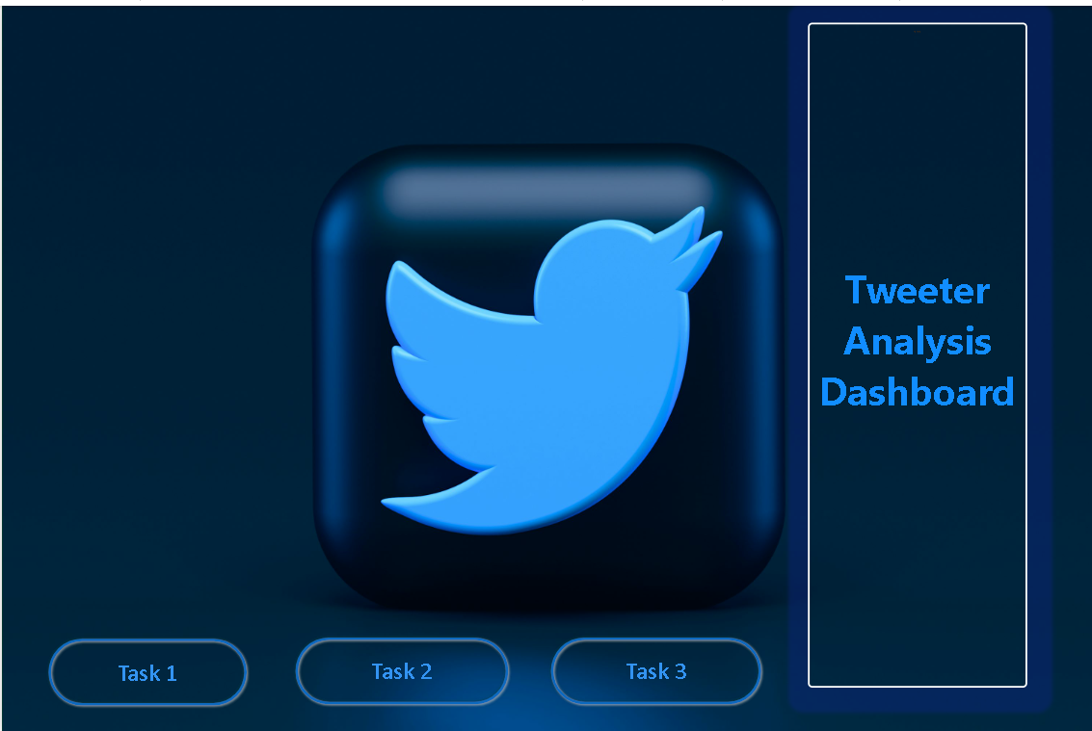

**Task1:**

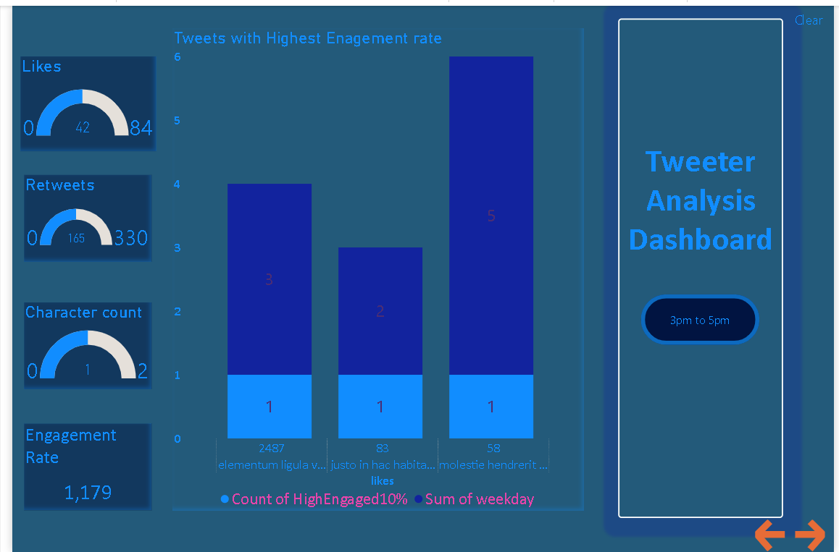

**Task2**: 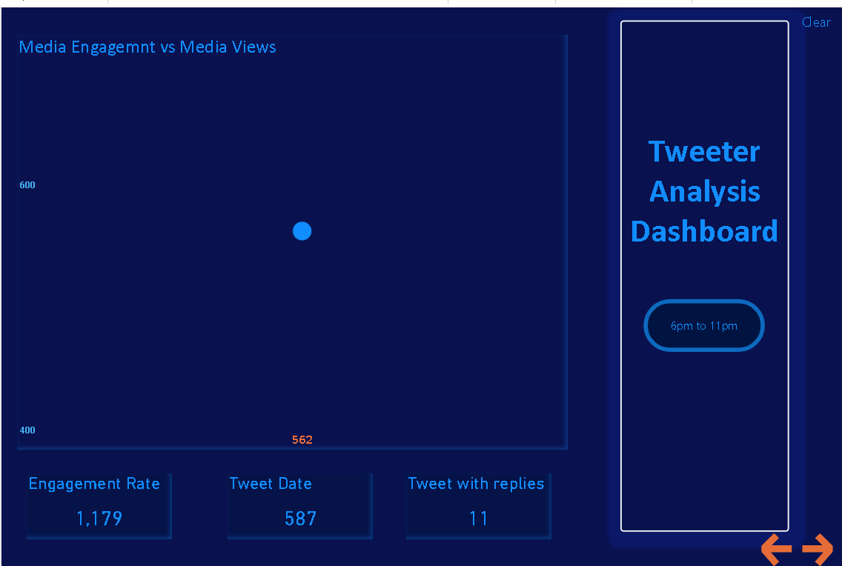**Task3**: 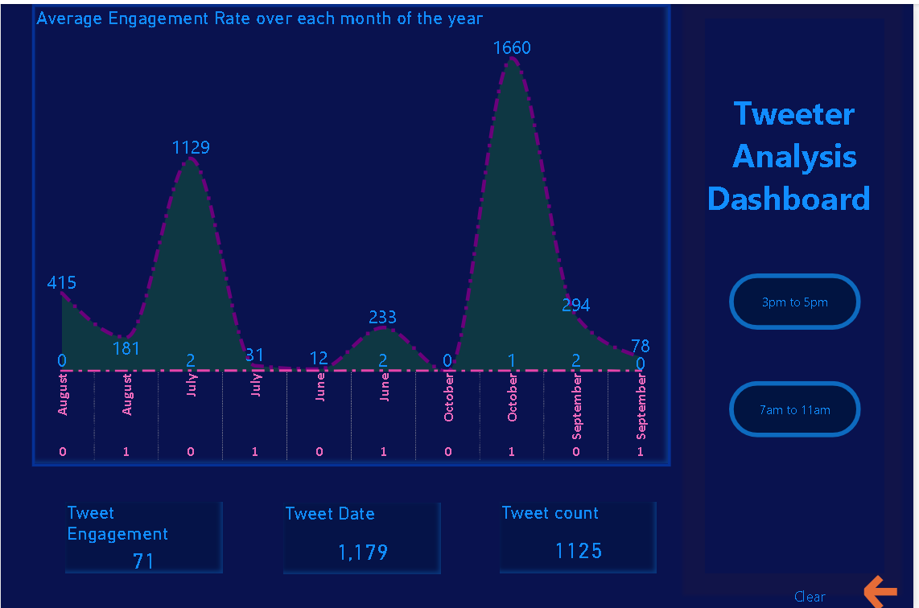

**Conclusion:**

This internship provided me with practical experience in Power BI, enhancing my skills in data visualization, advanced filtering, and social media analytics. I learned to develop dynamic dashboards with complex conditions, which improved my problem-solving abilities. The project was a valuable learning experience that prepared me for future roles in data analytics and business intelligence. This internship enhanced my Power BI skills and provided valuable experience in advanced data visualization and filtering techniques. I gained practical knowledge in analyzing social media engagement, which has equipped me for future roles in data analytics. Overall, this project was a rewarding learning experience that significantly contributed to my professional growth.